Help Wanted: Part-Time Park Maintenance Worker

Job Title: Part-Time Park Maintenance Worker
Reports To: Park Field Supervisor
Hourly Wage Range: $13.00 - $15.00
Hours Per Week: 20 or less
Classification: Part-Time, Pro-rated vacation and sick leave

OVERVIEW:
Performs general maintenance, repair and construction on park grounds, facilities, and trails

DUTIES & RESPONSIBILITIES:
- Cleans, maintains, repairs, and constructs park facilities, grounds and trails.
- Assists with landscaping, horticultural, and forestry projects.
- Assists with noxious weed management.
- Maintains and repairs landscaped areas, including turf, trees, shrubs and irrigation.
- Operates mowers and other mid-sized motorized equipment.
- Operates hand and powered tools.
- Prepares and maintains the district’s sport fields for practice and game play, including dragging, harrowing, and watering playing surfaces; marking fields. Identifies and eliminates safety hazards.
- Perform snow removal and ice control duties.
- Assists with new construction and remodeling in such areas as carpentry, painting, plumbing, concrete work, excavation, wildlife habitat and upland natural areas.
- Assists with irrigation system installation and maintenance.
- Assists with set up and operation of special events.
- Communicates openly and constructively with supervisor and district employees to enable efficient decision-making and positive morale.
- Maintains equipment in clean and safe condition; operate equipment safely at all times.
- Promotes safe conditions in all park facilities.
- Provides assistance and guidance to public park users as needed.
- Performs other duties as assigned.
BASIC KNOWLEDGE:
Basic knowledge of the principles, practices and methods used in horticulture, park maintenance repair and construction, forestry, and trail construction; maintenance and safe operation of powered equipment and hand tools.

SKILL & ABILITY:
Skill and ability to safely operate powered equipment and hand tools; understand and follow oral and written instructions; work independently, exercise initiative and good judgment; perform physical labor, lift heavy objects, and traverse rough terrain on job sites; establish and maintain effective, cooperative and respectful working relationships with all contacts.
EXPERIENCE & TRAINING:
- High School diploma or equivalence; AND
- One year experience in park maintenance, horticulture and landscaping, irrigation technology, or construction; OR
- Any satisfactory combination of experience and training which demonstrates the knowledge, skills and ability to perform the above described work.
LICENSES: Valid driver’s license is required.

WORKING CONDITIONS:
Work is performed primarily outdoors in a variety of conditions including: excessive temperatures, inclement weather and exposure to various hazardous chemicals. Daily precise control of fingers and hand movement. Daily standing or sitting for prolong periods of time. Occasional lifting, moving, dragging, pushing and carrying of heavy objects (up to 50 pounds unassisted). Occasional crouching, crawling, bending, kneeling, climbing or balancing. Occasional exposure to hazardous chemicals, vibration and fumes. Occasional dealing with distraught or difficult individuals. Daily operation of a motor vehicle on public roadways. May require emergency call-out during off duty hours.

Contact: Northern Wasco County Parks
& Recreation District (NWPRD) for more information
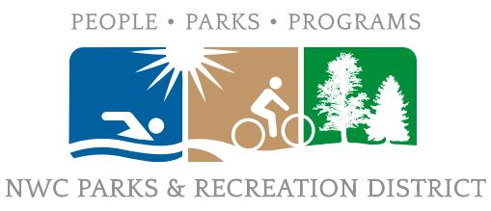
(541) 296-9533
www.nwprd.org
602 W. 2nd St.
The Dalles, OR 97058

www.nwprd.org
(541) 296-9533

