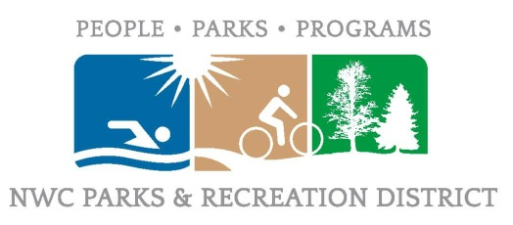
Northern Wasco County Parks & Recreation District
602 W 2nd St. The Dalles, OR 97058
Budget Hearing
May 17th, 2022

Brewster Whitmire called the meeting to order at 5:29pm.
ROLL CALL:
Budget Hearing Members- Tracy Dugick (via Zoom), Brewster Whitmire, Annette Byers, Rachel Carter (Via Zoom).
Budget Hearing Members Non-Present- Ellen Woods.
NWPRD Staff- Scott Baker, Kailynn Elliott, Todd Wheeler
Others Present – None.

APPROVAL OF AGENDA:
Brewster Whitmire asked if there was a motion to approve the agenda. Annette Byers made a motion to approve the agenda as-is. Rachel Carter seconded the motion. The motion passed unanimously.

APPROVAL OF MINUTES:
Brewster Whitmire asked if there was a motion to approve the minutes from the April 12th Budget Committee Meeting. Annette Byers made a motion to approve the minutes. Rachel Carter seconded the motion. The motion passed unanimously.

PUBLIC COMMENT: None.

DELIBERATIONS: None.

Brewster Whitmire adjourned the meeting at 5:31 pm.

Attested to:

Board President Board Secretary

